
RAJALAKSHMI INSTITUTE OF TECHNOLOGY
(An Autonomous Institution, Affiliated to Anna University, Chennai)

DEPARTMENT OF CSE (ARTIFICIAL INTELLIGENCE AND MACHINE LEARNING)
ACADEMIC YEAR 2025 - 2026
SEMESTER III
ARTIFICIAL INTELLIGENCE LABORATORY
MINI PROJECT REPORT

REGISTER NUMBER | 2117240030036
NAME | HANIF RAGHMAN.D
PROJECT TITLE | TIC TAC TOE GAME
DATE OF SUBMISSION | 28/10/25
FACULTY IN-CHARGE | Mrs. M. Divya

Signature of Faculty In-charge

INTRODUCTION
- This project is a Python-based implementation of the classic Tic-Tac-Toe game, enhanced with an intelligent AI opponent using the Minimax algorithm with Alpha-Beta pruning. Built using the Tkinter GUI library, the game allows a human player to compete against the computer in a visually interactive 3x3 grid.
- The AI evaluates all possible moves and selects the optimal one by minimizing the number of steps to victory while pruning unnecessary branches—making it both efficient and unbeatable. The interface is simple, responsive, and designed for quick gameplay with automatic win/draw detection.

PROBLEM STATEMENT
- Traditional Tic-Tac-Toe games offer limited challenge when played against static or random opponents. To create a more engaging and intelligent experience, this project aims to develop a Tic-Tac-Toe game with an AI opponent that uses the Minimax algorithm with Alpha-Beta pruning to make optimal decisions. The goal is to simulate a strategic two-player game where the AI can evaluate future moves, block the human player, and maximize its chances of winning—all within a responsive graphical interface built using Python’s Tkinter library.

GOAL
- The primary goal of this project is to design and implement a smart, interactive Tic-Tac-Toe game where a human player competes against an AI opponent capable of making optimal decisions. By integrating the Minimax algorithm with Alpha-Beta pruning, the AI can efficiently evaluate game states and respond with strategic moves that challenge the player and prevent predictable outcomes.

- This project also aims to:
- Demonstrate the practical application of game theory and search algorithms
- Build a clean and responsive GUI using Tkinter
- Create a fun, educational tool that showcases how AI can simulate intelligent behavior in simple games

THEORETICAL BACKGROUND
- This project combines game theory, AI algorithms, and GUI development to create an intelligent Tic-Tac-Toe game. The game is built using Python’s Tkinter library, which provides a simple way to design interactive graphical interfaces.
- At the core of the AI is the Minimax algorithm, a decision-making strategy used in two-player games. It assumes both players play optimally and evaluates all possible moves to choose the best one. To improve efficiency, Alpha-Beta pruning is applied. This technique skips unnecessary branches in the decision tree, reducing computation time without affecting the outcome.
- Tic-Tac-Toe itself is a simple but strategic game played on a 3x3 grid. The AI uses Minimax to simulate future moves and counter the human player’s strategy, making it nearly impossible to beat. The GUI allows users to play by clicking buttons, and the game automatically detects wins, losses, and draws.
- This combination of logic, optimization, and interface design makes the project a practical demonstration of how AI can be applied to real-time decision-making in games.

ALGORITHM EXPLANATION WITH EXAMPLE
🔹 Minimax Overview
Minimax is a recursive algorithm used in two-player games to find the best move by simulating all possible future moves. It assumes:
- The AI (maximizer) wants to maximize its score.
- The human (minimizer) wants to minimize the AI’s score.
Each move is scored:
- +10 for AI win
- –10 for Human win
- 0 for draw
The algorithm explores all possible moves, assigns scores, and chooses the move with the best outcome.
🔹 Alpha-Beta Pruning
Alpha-Beta pruning improves Minimax by skipping branches that won’t affect the final decision:
- Alpha: best score the maximizer (AI) can guarantee
- Beta: best score the minimizer (Human) can guarantee If Alpha ≥ Beta, further exploration is stopped (pruned).
Example: AI's Turn on This Board
X | O | X --------- O | X | --------- | | O
Let’s say it’s AI’s turn (O). Empty cells are at (1,2), (2,0), and (2,1).
Step-by-Step:
- AI tries (1,2):
  - Human responds optimally.
  - Minimax simulates all outcomes.
  - Score calculated: e.g., 0 (draw)
- AI tries (2,0):
  - Human responds.
  - Score: –10 (human wins)
- AI tries (2,1):
- Human responds.
- Score: +10 (AI wins)
✅ Minimax chooses (2,1) because it leads to the highest score (+10).
Alpha-Beta pruning skips branches where the score is already worse than a previously found move—saving time and speeding up decision-making.

IMPLEMENTATION AND CODE
import tkinter as tk
from tkinter import messagebox

# Constants
HUMAN = 'X'
AI = 'O'
EMPTY = ''

class TicTacToe:
def __init__(self, root):
self.root = root
self.root.title("Tic-Tac-Toe with Alpha-Beta Pruning")
self.board = [[EMPTY for _ in range(3)] for _ in range(3)]
self.buttons = [[None for _ in range(3)] for _ in range(3)]
self.game_over = False
self.create_board()

def create_board(self):
for i in range(3):
for j in range(3):
btn = tk.Button(self.root, text='', font=('Arial', 32), width=5, height=2,
command=lambda x=i, y=j: self.player_move(x, y))
btn.grid(row=i, column=j)
self.buttons[i][j] = btn

def player_move(self, x, y):
if not self.game_over and self.board[x][y] == EMPTY:
self.board[x][y] = HUMAN
self.buttons[x][y]['text'] = HUMAN
if self.check_winner(HUMAN):
self.end_game("You Win!")
elif self.is_draw():
self.end_game("It's a Draw!")
else:
self.root.after(500, self.ai_move)

def ai_move(self):
best_score = float('-inf')
best_move = None
for i in range(3):
for j in range(3):
if self.board[i][j] == EMPTY:
self.board[i][j] = AI
score = self.minimax(0, False, float('-inf'), float('inf'))
self.board[i][j] = EMPTY
if score > best_score:
best_score = score
best_move = (i, j)
if best_move:
i, j = best_move
self.board[i][j] = AI
self.buttons[i][j]['text'] = AI
if self.check_winner(AI):
self.end_game("AI Wins!")
elif self.is_draw():
self.end_game("It's a Draw!")

def minimax(self, depth, is_maximizing, alpha, beta):
if self.check_winner(AI):
return 10 - depth
elif self.check_winner(HUMAN):
return depth - 10
elif self.is_draw():
return 0

if is_maximizing:
max_eval = float('-inf')
for i in range(3):
for j in range(3):
if self.board[i][j] == EMPTY:
self.board[i][j] = AI
eval = self.minimax(depth + 1, False, alpha, beta)
self.board[i][j] = EMPTY
max_eval = max(max_eval, eval)
alpha = max(alpha, eval)
if beta <= alpha:
break
return max_eval
else:
min_eval = float('inf')
for i in range(3):
for j in range(3):
if self.board[i][j] == EMPTY:
self.board[i][j] = HUMAN
eval = self.minimax(depth + 1, True, alpha, beta)
self.board[i][j] = EMPTY
min_eval = min(min_eval, eval)
beta = min(beta, eval)
if beta <= alpha:
break
return min_eval

def check_winner(self, player):
for i in range(3):
if all(self.board[i][j] == player for j in range(3)):
return True
if all(self.board[j][i] == player for j in range(3)):
return True
if all(self.board[i][i] == player for i in range(3)):
return True
if all(self.board[i][2 - i] == player for i in range(3)):
return True
return False

def is_draw(self):
return all(self.board[i][j] != EMPTY for i in range(3) for j in range(3))

def end_game(self, message):
self.game_over = True
messagebox.showinfo("Game Over", message)

# Run the application
if __name__ == "__main__":
root = tk.Tk()
game = TicTacToe(root)
root.mainloop()
OUTPUT
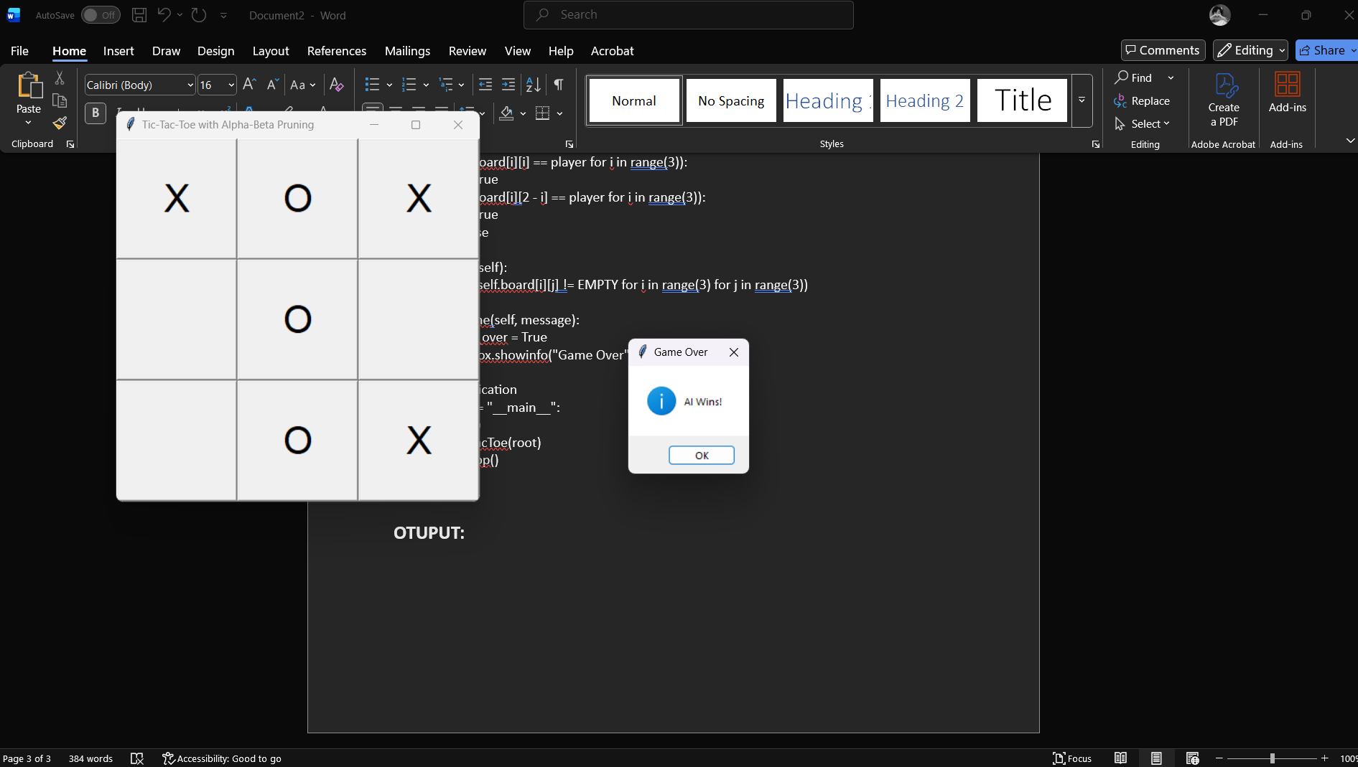
RESULTS AND FUTURE ENHANCEMENT
- The game runs successfully with a clean GUI and unbeatable AI using Minimax with Alpha-Beta pruning. It detects wins, losses, and draws accurately, offering smooth gameplay.

- Future Enhancement

- Add restart and score tracking
- Include difficulty levels
- Convert to web/mobile version
- Add sound and animations

Git Hub Link of the project and report | https://github.com/hanifraghman/tic-tac-toe-ai.git
REFERENCES
- Russell, S., & Norvig, P. (2010). Artificial Intelligence: A Modern Approach. Pearson Education.
- Python Software Foundation. https://www.python.org
- Tkinter GUI Documentation. https://docs.python.org/3/library/tkinter.html
- GeeksforGeeks – Minimax Algorithm: https://www.geeksforgeeks.org/minimax-algorithm-in-game-theory
- Real Python – Tkinter Tutorial: https://realpython.com/python-gui-tkinter

